

### Department Of Computer Applications

**KIET GROUP OF INSTITUTIONS, DELHI-NCR, GHAZIABAD-201206**

**SYNOPSIS**

**Report on**

**Flipkart Reviews Extraction and Sentiment Analysis**

**by**

TRIPTI TOMAR

2200290140161

**Session:2023-2024 (III Semester)**

Under the supervision of

**Dr. Sangeeta Arora**

### KIET Group of Institutions, Delhi-NCR, Ghaziabad

**ABSTRACT**

Online shopping is a major part of people's life nowadays and product reviews plays an important role in it. The "Flipkart Reviews Extraction and Sentiment Analysis Project" aims to develop a comprehensive system for extracting product reviews from the popular e-commerce platform Flipkart, followed by a thorough sentiment analysis of these reviews. The project leverages Natural Language Processing (NLP) techniques to provide valuable insights into customer sentiments and preferences.

**The project consists of two main components:**

1. Review Extraction Module:

The system employs web scraping techniques to collect product reviews from Flipkart's website. It utilizes Python libraries such as Beautiful Soup and Selenium to navigate and extract structured data from the product pages. The extracted information includes user names, review text, ratings, and other relevant metadata.

2. Sentiment Analysis Module:

The sentiment analysis component employs advanced NLP models, potentially utilizing state-of-the-art architectures like BERT or Transformer-based models. The reviews are pre-processed to remove noise and irrelevant information, and then fed into the model for sentiment classification. The sentiment labels may include positive, negative, or neutral sentiments.

**Key steps in the sentiment analysis module:**

- Text pre-processing (tokenization, stop word removal, etc.)

- Feature extraction using word embeddings or other advanced techniques.

- Sentiment classification using machine learning models.

**The project aims to address the following objectives:**

- Provide an automated and scalable solution for extracting product reviews from Flipkart's platform.

- Perform sentiment analysis to categorize reviews into positive, negative, and neutral sentiments.

- Aggregate and present the sentiment analysis results in a user-friendly interface or dashboard.

**Potential applications of this project include:**

Businesses can utilize this tool to gain insights into customer sentiments towards specific products or brands, enabling them to refine their marketing strategies. Extracted reviews and sentiment analysis can be valuable in identifying areas for product improvement and innovation based on customer feedback. Understanding customer sentiments can help in improving customer service by addressing pain points and areas of dissatisfaction. Automating the process of reviewing and categorizing user-generated content for quality control and compliance.

By providing a seamless solution for extracting and analysing product reviews, this project contributes to enhancing decision-making processes for businesses operating in the e-commerce domain. Additionally, it offers a valuable tool for researchers and analysts interested in consumer behaviour and sentiment analysis within the e-commerce sector.

**TABLE OF CONTENTS**

Page Number

1. Introduction 4
2. Literature Review 5
3. Project Objective 6
4. Research Methodology 7
5. Project Outcome 8
6. Proposed Time Duration 9

References 10

**INTRODUCTION**

In the fast-paced realm of e-commerce, understanding customer sentiments and preferences is crucial for businesses aiming to stay competitive and relevant. The advent of online shopping has generated a vast repository of user-generated content, particularly in the form of product reviews. Extracting meaningful insights from this treasure trove of information holds immense potential for market research, product development, and customer engagement.

The "Flipkart Reviews Extraction and Sentiment Analysis" project sets out to revolutionize the way businesses interact with their customers on one of India's leading e-commerce platforms, Flipkart. By combining cutting-edge web scraping techniques with state-of-the-art Natural Language Processing (NLP) models, this project offers a comprehensive solution for extracting and analysing product reviews in an automated and scalable manner.

This project comprises two fundamental components: the Review Extraction Module and the Sentiment Analysis Module. The Review Extraction Module leverages web scraping technologies to systematically gather reviews from Flipkart's product listings. This module ensures that pertinent information including user names, review text, ratings, and additional metadata are captured accurately.

The Sentiment Analysis Module, on the other hand, utilizes advanced NLP models to discern the sentiments expressed within the extracted reviews. By employing techniques like tokenization, word embeddings, and sentiment classification, this module categorizes reviews into positive, negative, or neutral sentiments. These insights can be instrumental in guiding marketing strategies, enhancing product offerings, and improving customer satisfaction.

This project is poised to bring about a transformative impact on how businesses leverage customer feedback for informed decision-making. The applications are far-reaching, spanning from market research and competitor analysis to guiding product development and honing customer service strategies.

With this project, we embark on a journey towards unlocking the full potential of customer feedback in the digital age. By providing businesses with a powerful tool to navigate the complex landscape of online reviews, we aim to empower them to make data-driven decisions that resonate with their customers and drive success in the ever-evolving e-commerce ecosystem.

**Literature Review**

This literature review highlights the foundational knowledge and research that underpins the "Flipkart Reviews Extraction and Sentiment Analysis" project, encompassing web scraping techniques, NLP models for sentiment analysis, feature engineering, and ethical considerations in data extraction. Building upon this body of knowledge, the project aims to contribute to the field by providing a comprehensive solution for extracting and analysing product reviews from the Flipkart platform.

1. Web Scraping and Data Extraction Techniques: The foundation of any review’s extraction project lies in robust web scraping techniques. Scholars like Robert Meusel have explored the challenges and best practices associated with web scraping for information retrieval from dynamic and large-scale websites. Techniques such as Beautiful Soup and Selenium, commonly used in web scraping, have been discussed extensively in literature.

2. Natural Language Processing for Sentiment Analysis: The sentiment analysis aspect of the project heavily relies on Natural Language Processing (NLP) techniques. Researchers have made significant strides in sentiment analysis using NLP models like Support Vector Machines (SVM), Naive Bayes, and more recently, deep learning models like Convolutional Neural Networks (CNN) and Recurrent Neural Networks (RNN). The effectiveness of these models has been demonstrated in studies by Bo Pang and Yoon Kim.

3. Feature Engineering and Word Embeddings: Feature engineering plays a crucial role in the success of sentiment analysis models. Techniques like word embeddings, which represent words as continuous vectors, have demonstrated exceptional performance. Word2Vec and GloVe are two prominent word embedding models that have been widely adopted in sentiment analysis projects.

4. E-commerce and Customer Review Analysis: Studies in the domain of e-commerce and customer review analysis have provided valuable insights. Research by Xing Fang et al. (2016) delves into the impact of online reviews on consumer purchasing decisions. Understanding consumer behaviour in the e-commerce context is essential for deriving meaningful insights from reviews.

5. Ethical Considerations in Web Scraping and Data Usage: Given the nature of web scraping, ethical considerations are paramount. Scholars like Michael Zimmer (2010) have explored the ethical implications of web scraping, emphasizing the importance of transparency, privacy, and informed consent.

**Project Objective**

The primary objective of the "Flipkart Reviews Extraction and Sentiment Analysis" project is to develop a robust and automated system that effectively extracts product reviews from the Flipkart e-commerce platform and conducts a comprehensive sentiment analysis. The project aims to achieve the following specific goals:

1. Efficient Review Extraction and Sentiment Analysis Classification: Implement web scraping techniques to systematically and accurately extract product reviews from Flipkart's product listings. Ensure the extraction process is reliable, scalable, and capable of handling dynamic webpage elements and then apply advanced Natural Language Processing (NLP) techniques to perform sentiment analysis on the extracted reviews. Classify reviews into distinct categories of positive, negative, or neutral sentiments, providing a nuanced understanding of customer feedback.

2. Accuracy and Performance Optimization: Fine-tune the sentiment analysis module to maximize accuracy in sentiment classification. Employ techniques like feature engineering, word embeddings, and model selection to achieve optimal performance.

3. Data Integrity and Completeness: Ensure that the extracted data includes essential components such as user names, review texts, ratings, and additional metadata. Maintain data integrity and completeness to provide a reliable foundation for sentiment analysis.

4. User-Friendly Interface or Dashboard: Develop a user-friendly interface or dashboard to present the results of the sentiment analysis in a clear and accessible manner. Provide functionalities for users to interact with and explore the analysed data.

5. Scalability-Adaptability and Ethical Considerations: Ensure that the system is designed to handle a wide range of products and reviews, demonstrating scalability. Additionally, make provisions for the system to adapt to potential changes in Flipkart's webpage structure or policies. Also, address ethical considerations associated with web scraping and data usage. Ensure compliance with privacy regulations and industry standards, emphasizing transparency and user consent.

By achieving these objectives, the project aims to deliver a powerful tool that empowers businesses to extract valuable insights from customer feedback on Flipkart, enabling them to make informed decisions for marketing, product development, and customer engagement strategies.

**Research Methodology**

The "Flipkart Reviews Extraction and Sentiment Analysis" project encompasses several stages, each requiring specific research methodologies to ensure accuracy, reliability, and effectiveness. The methodology is structured as follows:

**1. Data Collection:** Web Scraping: Employ web scraping techniques using Python libraries such as Beautiful Soup and Selenium to collect product reviews from Flipkart's product listings. Develop scripts to navigate through pages, extract structured data including user names, review texts, ratings, and metadata.

**2. Data Preprocessing:** Text Cleaning: Remove HTML tags, special characters, and irrelevant information from the extracted reviews. Tokenization: Split reviews into tokens or words for further analysis. Stop word Removal: Eliminate common stop words that do not contribute significantly to sentiment analysis. Lemmatization or Stemming: Reduce words to their base forms to normalize the text.

**3. Sentiment Analysis:** Feature Extraction: Convert text data into numerical features using techniques like TF-IDF (Term Frequency-Inverse Document Frequency) or word embeddings like Word2Vec or GloVec. Model Selection: Choose an appropriate sentiment analysis model, such as Support Vector Machines (SVM), Naive Bayes, or deep learning models like Convolutional Neural Networks (CNNs) or Recurrent Neural Networks (RNNs). Training and Testing: Split the dataset into training and testing sets for model training and evaluation. Hyperparameter Tuning: Optimize model hyperparameters for improved accuracy. Validation: Validate the model's performance through metrics like accuracy, precision, recall, and F1-score. Testing and Validation: Conduct comprehensive testing, including unit testing, integration testing, and system testing, to verify the system's functionality and validate the system's performance by using diverse product categories and reviews.

**4. Ethical Considerations:** Address ethical concerns related to web scraping and data usage, including privacy and consent. Comply with relevant legal and ethical guidelines and regulations governing data collection and analysis.

**5. User Interface Development:** Develop a user-friendly interface or dashboard to present the results of sentiment analysis. Utilize web frameworks like Flask or web visualization libraries to create interactive data displays.

**6. Scalability and Adaptability:** Ensure the system can handle large volumes of data and adapt to potential changes in Flipkart's webpage structure. Implement error handling mechanisms to manage variations in data sources.

**Project Outcome**

The "Flipkart Reviews Extraction and Sentiment Analysis" project is anticipated to yield several significant outcomes that will benefit businesses, researchers, and analysts in the e-commerce domain. These outcomes encompass both tangible deliverables and intangible impacts. The project will deliver a robust and automated system capable of efficiently extracting product reviews from Flipkart's product listings. This system will save time and resources compared to manual data collection methods. The sentiment analysis module will provide detailed insights into customer sentiments towards products on Flipkart. Reviews will be categorized into positive, negative, or neutral sentiments, enabling businesses to understand customer preferences and pain points.

A user-friendly interface or dashboard will be developed to present the results of the sentiment analysis in an accessible and visually appealing manner. This interface will enable users to interact with and explore the analyzed data. Businesses can leverage the sentiment analysis results to make data-driven decisions regarding marketing strategies, product development, and customer service improvements. Understanding customer sentiments empowers businesses to align their offerings with customer expectations. The project outcomes will enable businesses to conduct market research and competitor analysis by gaining insights into customer sentiments towards specific products or brands on Flipkart. This information can inform market positioning and product differentiation strategies. Extracted reviews and sentiment analysis will serve as valuable feedback for product development teams. Identifying areas for improvement based on customer feedback can guide enhancements and innovations.

Understanding customer sentiments allows businesses to address pain points and areas of dissatisfaction, ultimately enhancing customer satisfaction and loyalty. The sentiment analysis results can be employed for automating the review categorization process, aiding in quality control and compliance for user-generated content. The project outcomes may serve as a valuable resource for researchers and analysts studying consumer behaviour, sentiment trends, and e-commerce dynamics. The insights generated can contribute to academic research and industry reports. The project's modular design and scalable architecture allow for future enhancements and adaptations to emerging technologies or changes in Flipkart's platform structure.

Overall, the "Flipkart Reviews Extraction and Sentiment Analysis" project aims to deliver a powerful tool that empowers businesses with valuable insights from customer feedback. It is expected to drive informed decision-making and enhance the customer experience in the dynamic landscape of e-commerce.

**PROPOSED TIME DURATION**

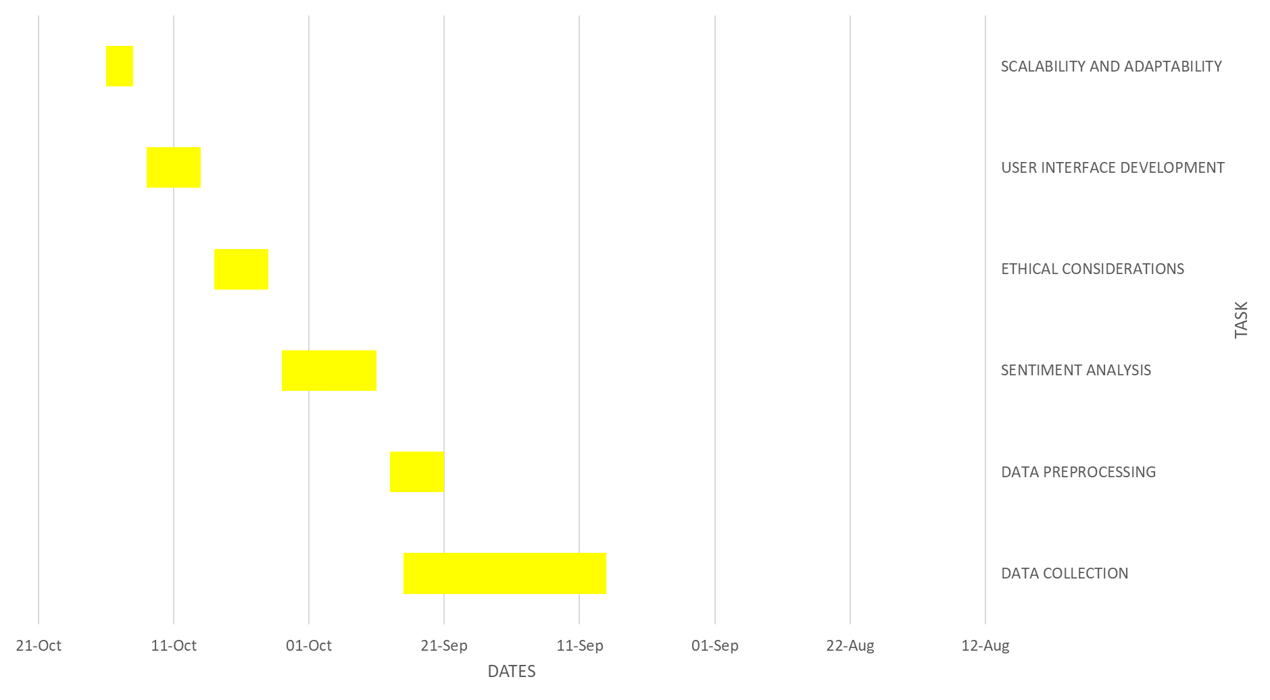

**REFERENCES**

* Meusel, R., Vigna, S., & Lehmberg, O. (2015). Learning to Extract Information for the Semantic Web from Web Pages. Web Engineering (ICWE), 188-206. *
* Pang, B., Lee, L., & Vaithyanathan, S. (2002). Thumbs up? sentiment classification using machine learning techniques. Proceedings of the ACL-02 conference on Empirical methods in natural language processing, 79-86.
* Kim, Y. (2014). Convolutional neural networks for sentence classification. arXiv preprint arXiv:1408.5882. *
* Mikolov, T., Sutskever, I., Chen, K., Corrado, G. S., & Dean, J. (2013). Distributed representations of words and phrases and their compositionality. In Advances in neural information processing systems, 3111-3119.
* Pennington, J., Socher, R., & Manning, C. D. (2014). GloVe: Global vectors for word representation. Proceedings of the 2014 conference on empirical methods in natural language processing (EMNLP), 1532-1543. *
* Fang, X., Zhang, J., Zhang, Z., & Li, Y. (2016). The impact of online consumer reviews on consumer purchasing intention: The moderating role of involvement. Decision Support Systems, 83, 36-44. *
* Zimmer, M. (2010). "But the data is already public": on the ethics of research in Facebook. Ethics and information technology, 12(4), 313-325. *